Low Level Design (LLD)

**Image Captioning**

Revision No: 1.0

Last Date of Revision: 23/11/2023.

**Document Version Control-**

|  |  |  |  |
| --- | --- | --- | --- |
| Date Issued | Version | Description | Author |
| **23/11/2023** | 1.0 | LLD – V- 1.0 | Mahesh. A |
|  |  |  |  |
|  |  |  |  |

**Contents -**

|  |  |
| --- | --- |
| **Description** | **Page**  **No.** |
| Document Version Control | 2 |
| 1. Introduction | 4 |
| 1.1 What is Low-Level design document | 4 |
| 1.2 Scope | 4 |
| 2. Architecture | 4 |
| 3. Architecture Description | 5 |
| 3.1 Data Accessing | 5 |
| 3.2 Data Pre-Processing | 5 |
| 3.3 Splitting the Data | 5 |
| 3.4 Model Building | 5 |
| 3.5 Create Front End User Module using flask | 5 |
| 3.6 Testing the Model | 6 |
|  |  |

1. **Introduction**
   1. **What is Low-Level design document?**

The goal of LLD or a low-level design document (LLDD) is to give the internal logical design of the actual programmed code for Image Captioning. LLD describes the class relations with predictors .It describes the modules so that the programmer can directly code the program from the document.

* 1. **Scope**

Low-level design (LLD) is a component-level design process that follows a step-by-step process. This process can be used for designing data structures, required software architecture, source code and ultimately, performance algorithms. Overall, the data organization may be defined during requirement analysis and then refined during data design work.

1. **Architecture**

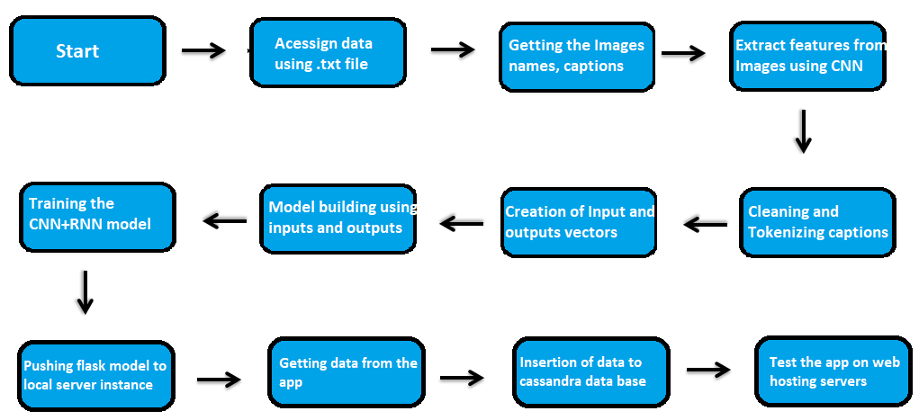

1. **Architecture Description**

# Data Accessing

We can access the data in the from the download link as available in the project. We load the data to the framework using the file open and readlines attributes.

# Data Pre-Processing

By the usage of the different data manipulation techniques like text cleaning, tokenizing and make all the features in numerical data type using CNN model for images and pad sequences for sequencing the captions

# Splitting the Data

We use train test split Sklearn function to split the data for training and validation

# Model Building

We will deploy CNN+RNN model

# Create Front End User Module using flask

Once the model is created download and save the model and now we create GUI for front end user using the flask incorporated with HTML, CSS. Align and map the user data to the data base created. From user data create the data frame and load it to the model for the prediction the same prediction is send back to the user GUI and well saved in the data base (MySQL).

# Testing the Model

* + - Verify whether the application is the loading on the local server instance.
    - Verify whether the user can access the application.
    - Verify the user can access the different fields for selection and can be visible
    - Once the user selection the fields and made the submit
    - Check the user can get the result or prediction.
    - Once he gets the prediction(Caption).
    - Check the data form the user and prediction from the model is loaded into the local MySQL and Cassandra database
    - Check the database and download the data…